

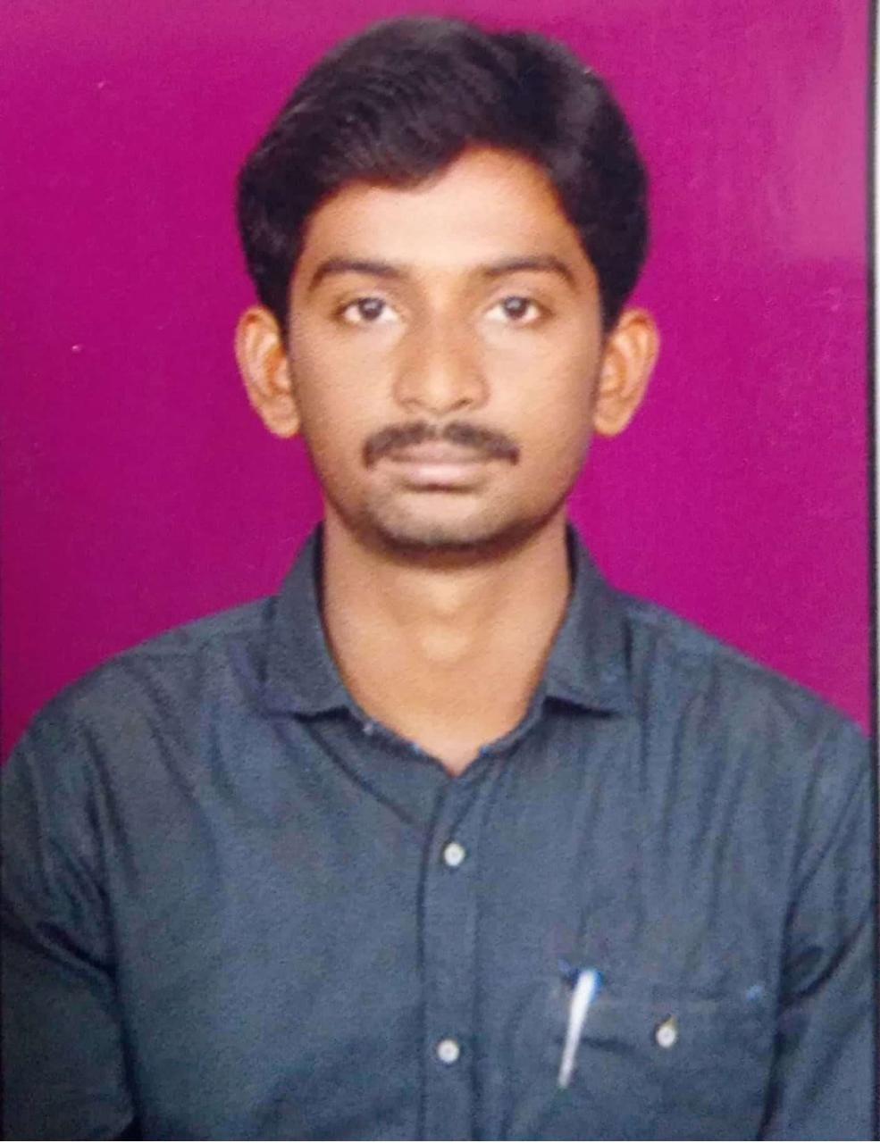

**Naga venkat Yellugari**

**Address:** #33, Madhav PG, church street, Murgesh palya.

**Phone No**. **:** +918328011719

**Email ID**: [y.nagavenkat@gmail.com](mailto:y.nagavenkat@gmail.com)

**CAREER OBJECTIVE:**

Seeking a challenging position in a reputed organization where I can learn new skills, expand my knowledge, and leverage my learnings. To get an opportunity where I can make the best of my potential and contribute to the organization’s growth.

EDUCATIONAL QUALIFICATION:

|  |  |  |  |  |
| --- | --- | --- | --- | --- |
| **Qualification** | **Institution** | **University/Board** | **Year of Passing** | **Percentage** |
| B. Tech (EEE) | Vaagdevi institute of science and technology | JNTU-A | 2021 | 63.71 |
| Intermediate (MPC) | The Nandhyal junior collage | Board of Intermediate AP | 2016 | 72 |
| SSC | Sri Guru Raghavendra High School | Board of secondary AP | 2014 | 7.3 |

TECHNICAL SKILLS:

* Languages **:** SQL, MANUAL TESTING, SDLC
* Operating System **:** MS office, windows 11 & 10
* Data Base **:** SQL, My SQL
* Web Technologies **:** HTML

ACHIEVEMENTS & EXTRA CURRICULAR ACTIVITIES:

* Certified Awarded as NSS leader in university level (JNTUA).
* Best Student Awardee at school during X std.
* Awarded as runner in EEE club
* Organized “Sports Event” contest for INNOVITES -2K19.
* Participated and won prizes in **Sports** competition in Collage level.

**PERSONAL ATTRIBUTES :**

* Flexible
* Communication
* Punctual
* Ethical and loyal
* Customer service skills
* Problem solving

PROJECT DETAILS:

* Project Name **:** Modified PQ-Theory-based control of solar-PV-integrated UPQC-s
* Tool **:** “MATLAB software(R2009)”
* Role **:** Team Member
* Description:

This project is an used to the power quality improvement, thus can increase the functionality of the system, by modified PQ-theory-based control of a solar photovoltaic (PV)-array-integrated unified power quality conditioner (PV-UPQC-S).

# PERSONAL DETAILS:

Father’s Name : Y Venkata Ramana

Date of Birth : 31/03/1999

Language Known : English, Telugu.

Sex : Male

Marital Status : Single

Nationality : Indian

Strengths : Quick learner, self-motivated, Leadership skills, Enthusiasm.

**DECLARATION**

I hereby declare that the details above are correct and true to the best of my knowledge.

**Place:** Bangalore **Signature**

**Naga venkat Yellugari**